**Linux Installation**

# Identification of Distribution

Linux is best known for open-source operating system that sits underneath of all the other computer software. It receives request from software programs and relay theses request to computer’s hardware. As open-source, they are freely distributed that can be installed to pc’s, laptop’s, video game consoles, servers and almost everywhere. Lots of Linux are available in the market like Ubuntu, Linux mint, Deepin, Fedora, Red Hat Enterprise Linux (for server), Oracle Linux etc. Here we will be using Oracle Linux. (Grimmer)

Why Oracle Linux?

Oracle Linux is a binary clone of Red Hat Enterprise Linux (RHEL) distribution. Oracle Linux is not freely available for Enterprise; we have to buy License to use it in enterprise but for study purpose, we use for free. We used oracle Linux as a server because both oracle database and oracle Linux are supported by Oracle Corporation which reduces any restrictions or compatibility issues. Oracle Virtual box was used to setup Oracle Linux inside Window 10.

Why Oracle Virtual Box?

In 2010, Virtual box was acquired by Oracle Corporation from Sun Microsoft. It lets us to operate oracle Linux inside our Window Operating where changes made inside it won’t affect host Operating system. Oracle Virtual box was choosey because Oracle Linux, Oracle database and Virtual box are supported by Oracle Corporation which reduces compatibility issues.

# Installation

## i. Minimum Requirements

**Virtual box**

Virtual box is a technology emulates system hardware using software that provides way to separate physical hardware and software inside a single system. Here, Virtualization is used for oracle database server. The host computer must have following minimum requirement along with guest operating system supported OS like window 7,8,10 for virtual box.

*Processor:* Any recent Intel or AMD processor should do

*Memory:* Minimum 512MB but need to configure what operating system needs to run comfortably. Here for Linux operating system, 8GB was configured.

*Hard disk:* IDE, SATA and SCSI are supported and memory needed to configure which OS we want to run. Virtual box itself doesn’t need much space. 1TB HDD is configured here.

**Oracle Linux inside Virtual box**

Linux OS should be installed in system, if we meet following minimum requirements.

1. Physical RAM

To perform optimal operation for oracle database server, 4 GB RAM or more should be available into system.

1. Physical Hard disk

## ii. Key stages of Installation

### Linux installation

Oracle Linux is installed inside Virtual box and here are key steps while installing Linux:

* 1. Creating Oracle Vdi file

Open Virtual box, Click to *New* and follow as in figure bellow:

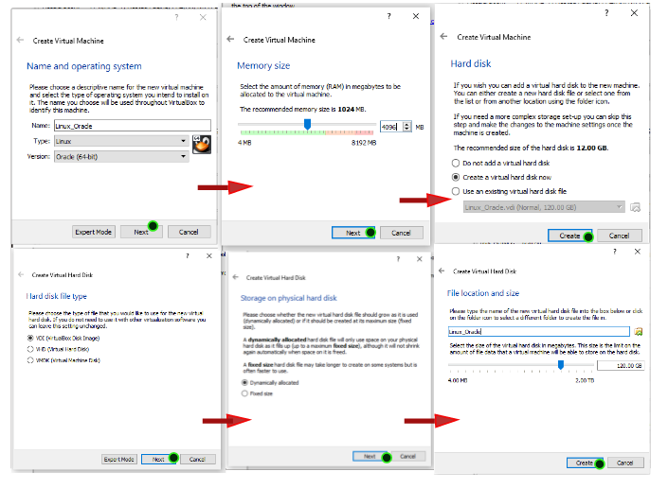

Figure : Creating VDI file for Linux

Now, Click *Start* to the top right corner, Chose the OS which you wish to install as bellow:

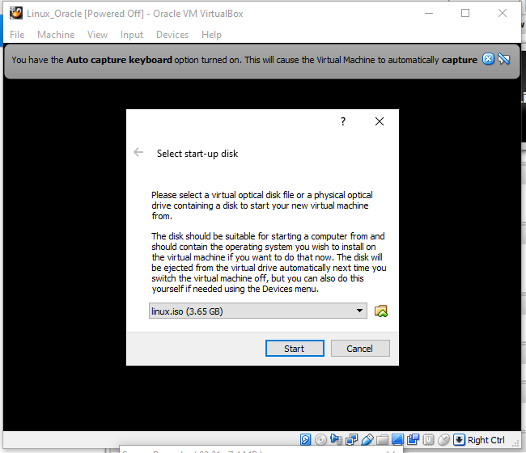

Figure : Chose oracle file

Here, Oracle Linux iso file was chosen and clicked to *start* and installation begins.

* 1. Testing installation media

This phase checks the CD/DVD’s problems like crupted or not of installation CD. Here, we are using ISO file, so we *Skip* this process.

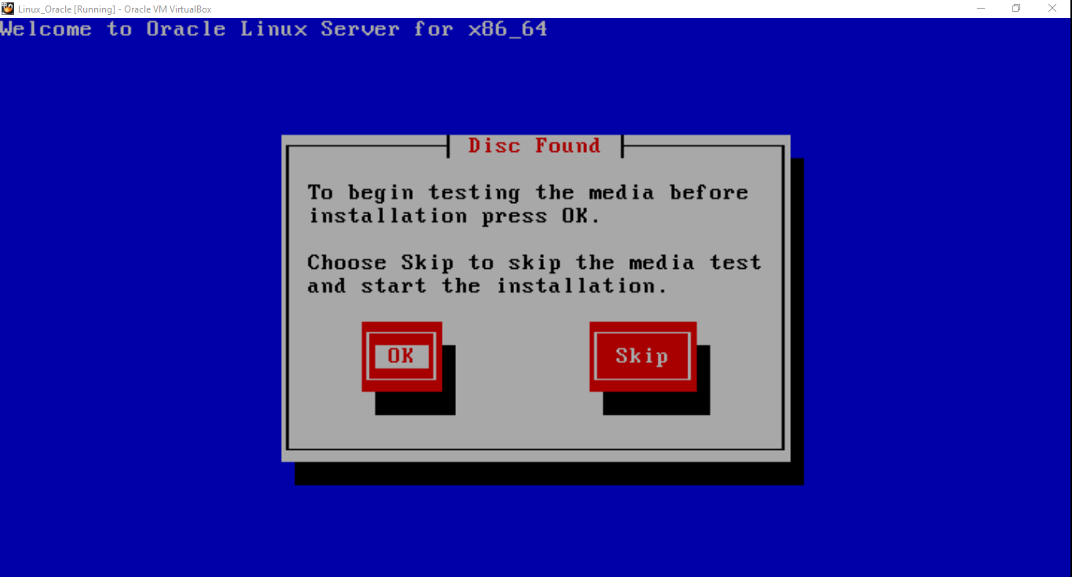

Figure : Testing media before installation

* 1. Language Setup

Language is setup as ***English*** and keyword formation of ***US******English*** as figure below:

* 1. Data storage Setup

Basic Storage device is selected and click *next.*

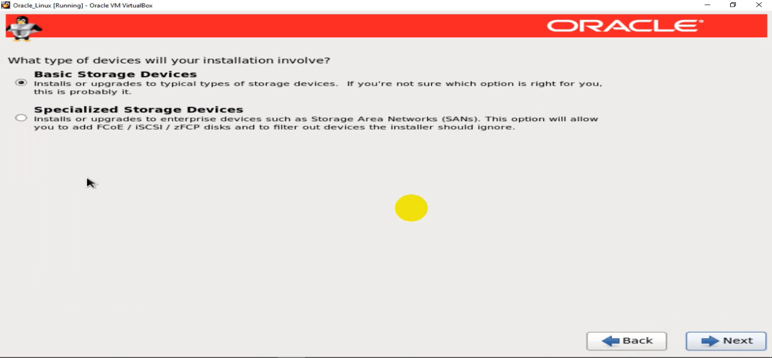

Figure : Device Storage type

A new window opens with options either to keep data or discard. Here, we will ***discard any data***and click next.

* 1. Hostname configuration

Hostname is default provided. We should not change this host name in education purpose OS.

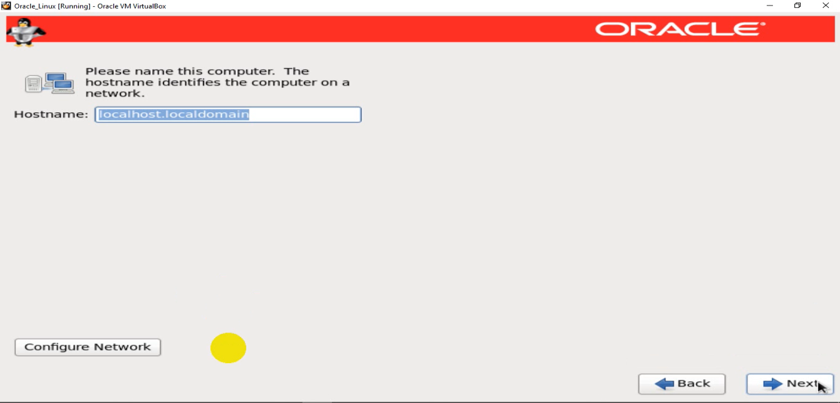

Figure : Host name configuration

* 1. Date and time configuration

Oracle Linux is not supported in Nepal time zone. So, we should provide time zone supported by Oracle Linux. *New York* time zone is configured as in figure below:

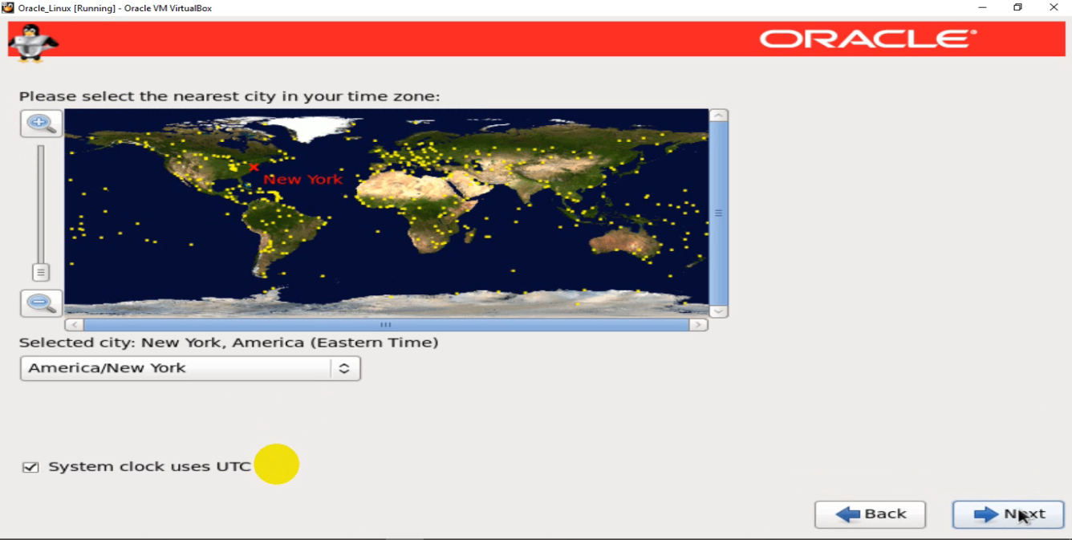

Figure : Time Zone Configuration

* 1. Root password setup

Root account password used for administering the system is provided. Here in this case, I have used simply **password** as password.

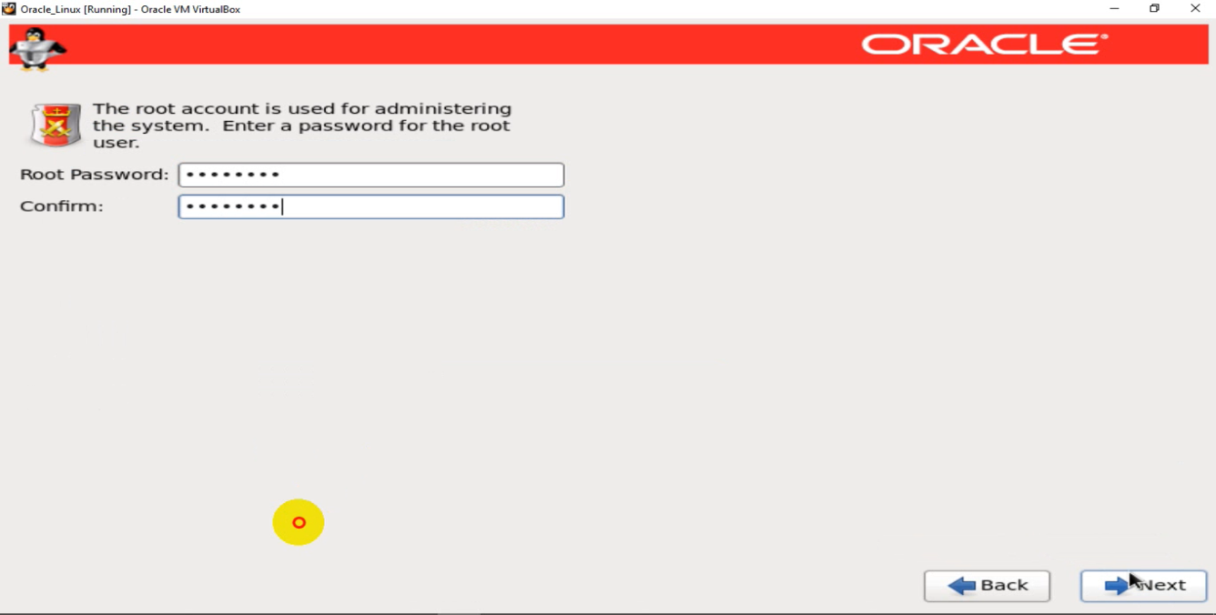

Figure : Root password setup

* 1. Installation type

Lots of installation options are available. Here, this server is being developed for oracle database and we will be using custom Layout. Select *create custom Layout* as in figure below:

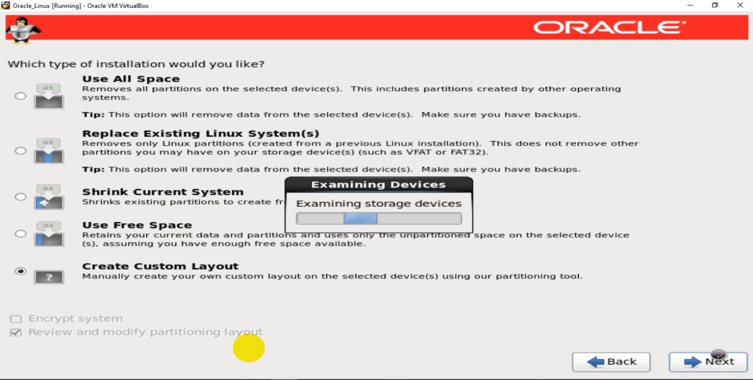

Figure : Custom Layout installation

* 1. Custom partition

Configure system partition as needed.

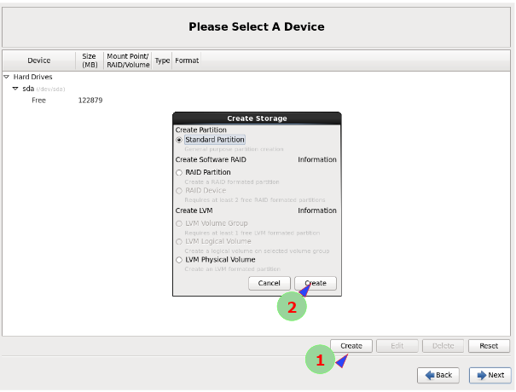

Figure : Disk partition configuration

Here, click to *create*. Then select *standard partition* type and click to *create*. A new window appears and there we have to allocate space for specific disk type.

* 1. Custom allocation of space for different drives

There are different partitions to be created. Different size is allocated to different partition as

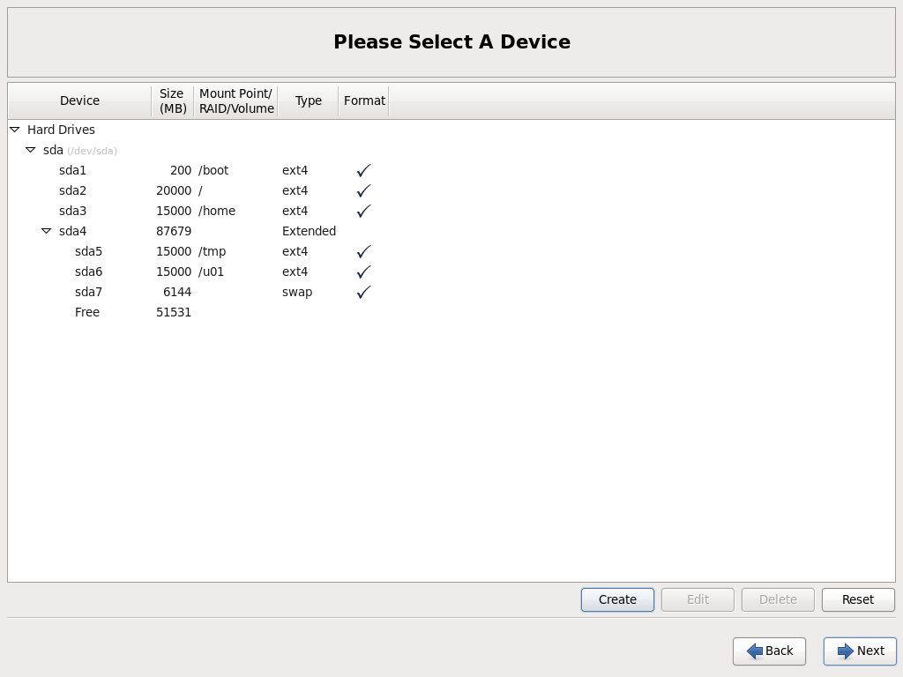

|  |  |  |
| --- | --- | --- |
| S/N | Partition name | Size(MB) |
| 1. | /boot | 200 |
| 2. | / (root) | 20000 |
| 3. | /home | 15000 |
| 4. | /temp | 15000 |
| 5. | /u01 | 15000 |
| 6. | Swap | 6144 (1.5 times of RAM size) |

Table 1: Drive partition size

To provide size for different drive, select drive name in *mount point* and size as below.

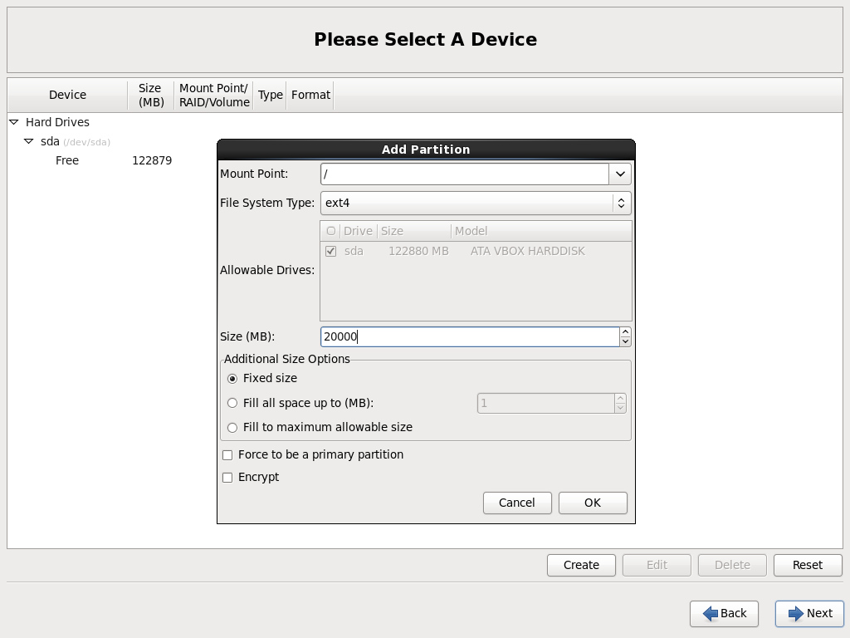

* 1. Selecting bootloader operating disk

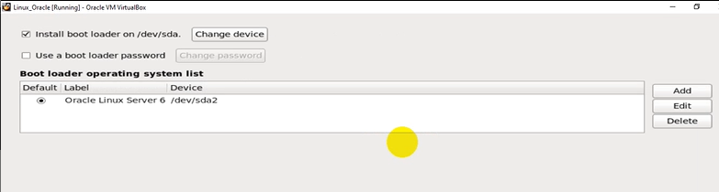

* 1. Customization of software

To operate as server, we have customized different set of software required. Some GUI Configuration are required to install oracle in system.

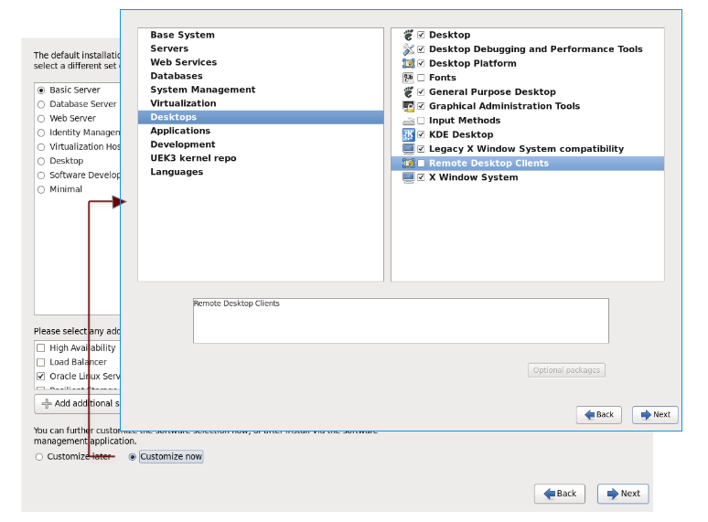

Finally, Configuration of oracle Linux is done according to oracle database requirements.

* 1. License Agreements

As we reboot, some setup is still to figure out as bellow:

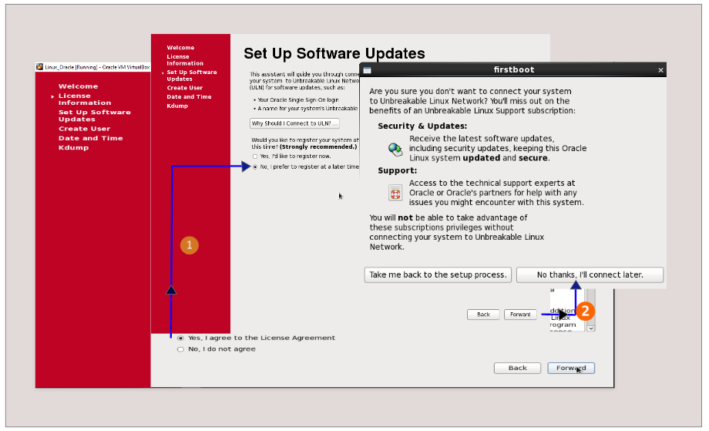

Here, License agreement must be accepted and we do not connect system to internet connection for regular updates. Updates are manually done when required.

* 1. User/Date and time setup

No any user is created with Date/time being manually set.

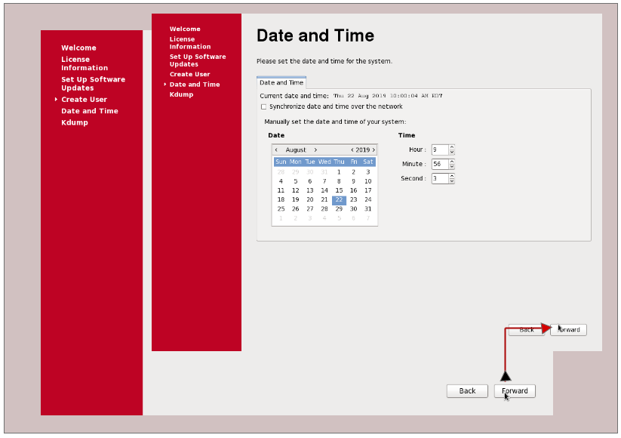

* 1. Kdump configuration

Kdump is crash-dumping mechanism, which enables the system to boot from the context of another kernel. This second kernel reserves a small amount of memory, and its only purpose is to capture the core dump image in case of system crashes. Kdump enabled system to tackle the unfortunate system crashes issues.

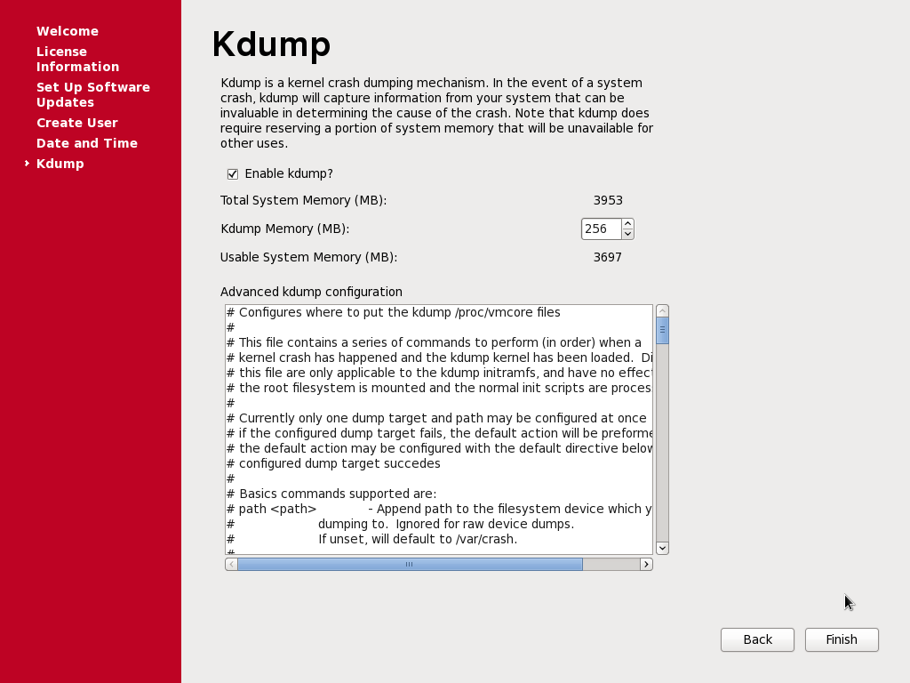

### Yum configuration (yellowdog Updater, Modified)

Unless RPM package installation, yum automatically installs all the packages dependencies while installing or updating a software package. Yum utilities downloads package headers and packages from repositories.

Steps for yum configuration:

1. Create a directory DISK1 under root {command: mkdir -p /stage/Disk1}
2. Copy three installation packages from external USB to Disk1 created

{Command: cp -r /media/RH<TAB>/* /stage/Disk1}

1. Then change directory from Disk1 to packages { Command: cd /stage/Disk1/Packages}
2. Install all the three packages using rpm {command: rpm –ivh <package name>}
3. Now, manage the files installed {command: createrepo /stage/Disk1/Packages}. A yum.repos.d file is created under /etc/
4. Go to yum.repos.d {command: cd /etc/yum.repos.d}. Removing public-yum-ol16-repo, a packages.repo file is created and we have to change this file.
5. Open the packages.repo {command: vi packages.repo} and replace with bellow given command:
6. Now you are ready with yum configuration. We ensured by installing Firefox with yum as bellow.

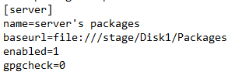

### Kernel configuration

In order to install oracle in system, we have make several changes in kernel. Change includes:

1. Edit sysctl.conf file with following commands {vi /etc/sysctl.conf}
2. Go to last line {ESC + G}, next line {ESC + o} and insert {ESC + i}. Copy the code and save {ESC + wq:}
3. Check whether the code is copied or not using {sysctl –p}.

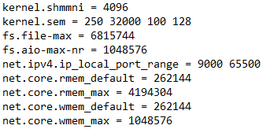

**ASM (Automatic storage management)**

Automatic storage management provides vertical integration of the file system and the volume management for oracle database files. An oracle ASM disk group is the collection of one or more oracle ASM disks managed as a logical unit. The data structures in a disk group are self-contained using some of the space for metadata needs.

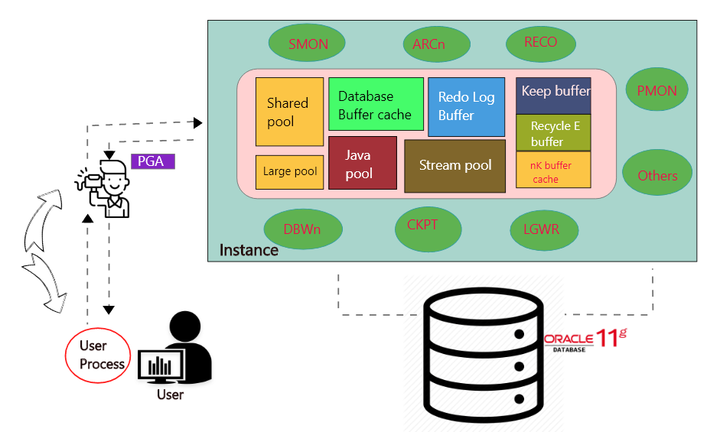

These are some component which helps to run the database.

Shred Pool: - It is a database data dictionary. This dictionary has complete information about the database.

Large Pool: - it handles space matter. In the database different tasks are done. Some task needs huge space and resource. This pool handle provides space and resource.

Database Buffer cache: - It main task is to hold the data.

Redo log: - Redo log handle the DML operations.

Java Pool: - it handles all java related execution and activity. Such as database creation.

Streams Pool: - Maintain channel.